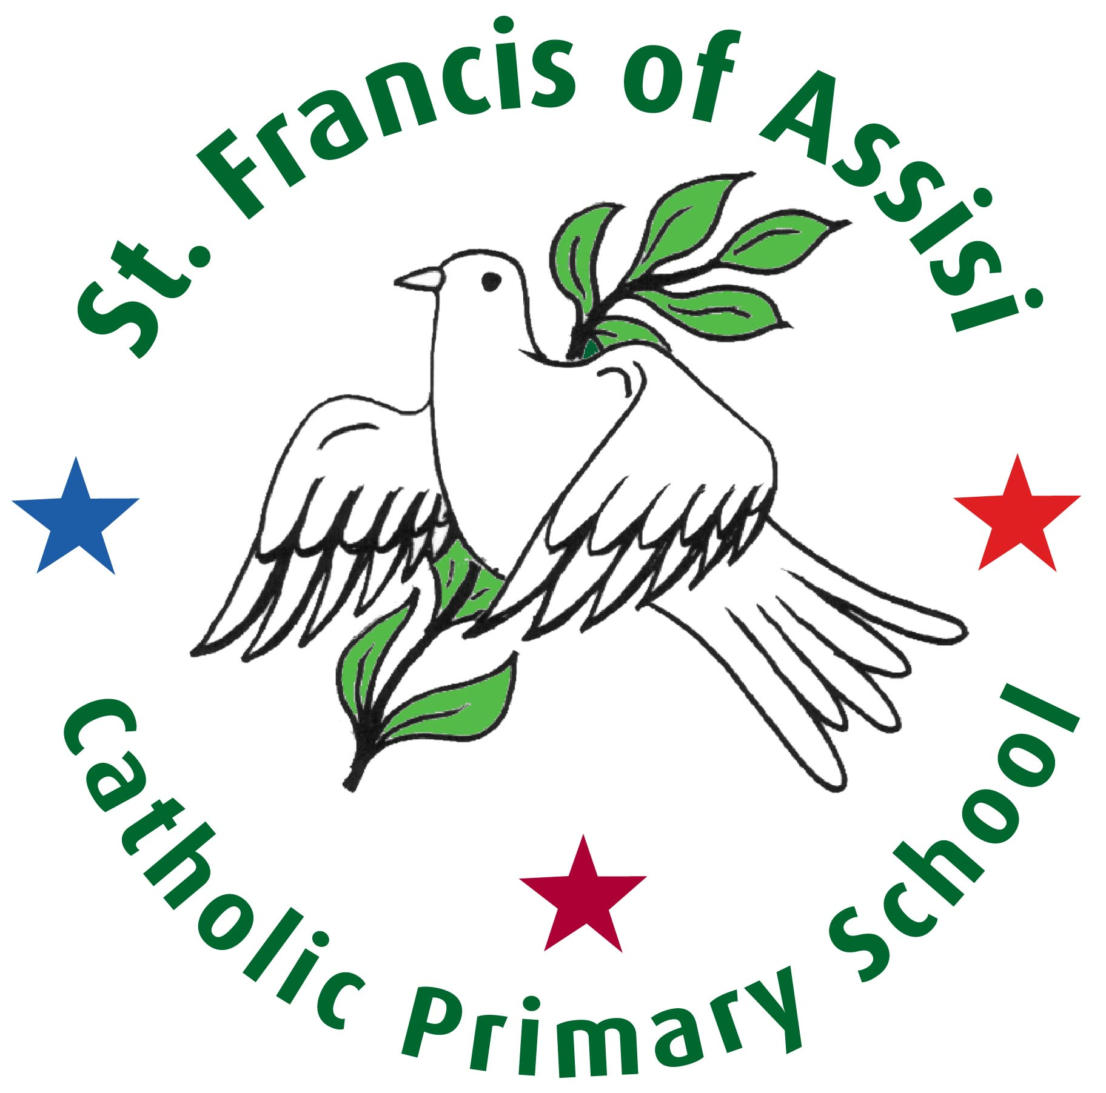

Collective Worship

At St. Francis of Assisi school

We love and grow in Christ

We live and learn in partnership

We build and share together

RE Coordinator | S. Currie
Chair of Governors | C. Eglin

September 2024

Our Mission Statement

At St. Francis of Assisi school

We love and grow in Christ

We live and learn in partnership

We build and share together

Collective worship in St Francis of Assisi Catholic Primary School is an integral part of school life. While respecting diversity of belief and commitment, it is Catholic in character and has Christ at its heart. It celebrates God’s presence in our lives and is concerned with giving glory, honour, praise and thanks to God. It reflects the tradition of the Church and its belief in the Holy Trinity.

Intent
The purpose of collective worship:
- To experience a sense of belonging and develop community spirit.
- To promote spiritual, cultural and moral development.
- To provide opportunity for children to share and express their thoughts and feelings.

The aims of collective worship:
- To provide opportunities for pupils to worship God, to consider spiritual and moral issues and to explore their own beliefs.
- To reflect on values and concerns of the school community and the wider community it serves.
- To deepen and widen a child’s emotional response.
- To enable children to gain insight into ways in which people express themselves within their faith commitments and to be sensitive to those different ways of responding.
- To encourage participation and response, through active involvement in the planning and presentation of worship.
- To develop community spirit, promote a common ethos and shared values, and reinforce positive attitudes.

The objectives of collective worship
To develop a sense of:
  - Awe, wonder and mystery.
  - Interdependence with the natural world.
  - Pattern, sequence and order.
  - Self-worth and value of others.

To develop an awareness:
  - That life involves choices of belief, attitude, behaviour and relationships.
  - That there are issues of meaning, purpose and value in life.

Implementation
At St Francis of Assisi Catholic Primary School, collective worship aims to provide opportunities for all pupils and staff to:
- Contemplate something of the mystery of God
- Reflect on spiritual and moral issues
- Explore their own beliefs
- Respond to and celebrate life
- Experience a sense of belonging and develop community spirit
- Develop a common ethos and shared values
- Enrich religious experience
- Grow in liturgical understanding and development
- Reinforce prayers which are part of the Catholic tradition
- Reinforce positive attitudes
- Participate fully
- Take time ‘to wonder at’, ‘to come to terms with’ and ‘to give worth to.’

Principles
All Acts of Worship in this school will:
  - Give glory and honour to God;
  - Be an enriching experience, fundamental to the life of the school and its Catholic character;
  - Develop in pupils skills that enable them to prepare, organise and lead worship rather than
always participating or contributing in a token way;
  - Give pupils positive liturgical experiences, appropriate to their age, aptitude and family
backgrounds in order to prepare them for the liturgical life of the Church.

In order to do this, celebrations will:
- be kept small wherever appropriate to help to personalise the experience;
- be timed appropriately for children’s age and development (for example 5-6 minutes for Key Stage 1 and 7-10 minutes for Key Stage 2)
- be simple, including a range of experiences offered in a variety of groupings and in a variety
of settings
- be held in a special, prayerful atmosphere including classrooms, school hall and prayer garden

Collective worship in our school will be:
  - properly planned (Gather, Listen, Respond, Go forth)
  - adequately resourced
  - recorded
  - monitored
  - evaluated

Collective Worship is carried out daily as part of an assembly or within individual classrooms.
On occasions, it takes place in St Francis of Assisi Church, outside in the school grounds and in our Prayer garden during the warmer months.
Monday: Whole school collective worship
Tuesday- Thursday: EYFS, KS 1 and KS 2 class based collective worship.
Friday: Key Stage collective worship.
Throughout the year special celebrations are held which encourage the children to share and quietly reflect on important events in the Church’s year. Some of the celebrations include:
KS2- St Francis of Assisi Feast Day Mass
EYFS- present the Nativity
KS1- perform a Christmas play about the Nativity
KS2- perform a Christmas Carol concert
KS1-KS2- present The Stations of the Cross
Rec- Y6- attend the Ash Wednesday Mass in school
Rec- Y6- attend Leaver’s Celebration

The experience of stillness, peace, awe, wonder, mystery, celebration, reverence and belonging are of central importance in promoting spiritual development. Such values will be explored, celebrated and reflected upon in Collective Worship in a manner that compliments the way they are taught in the classroom and communicated through the ethos of the school.

The Collective Worship Policy will be reviewed in September 2025.

