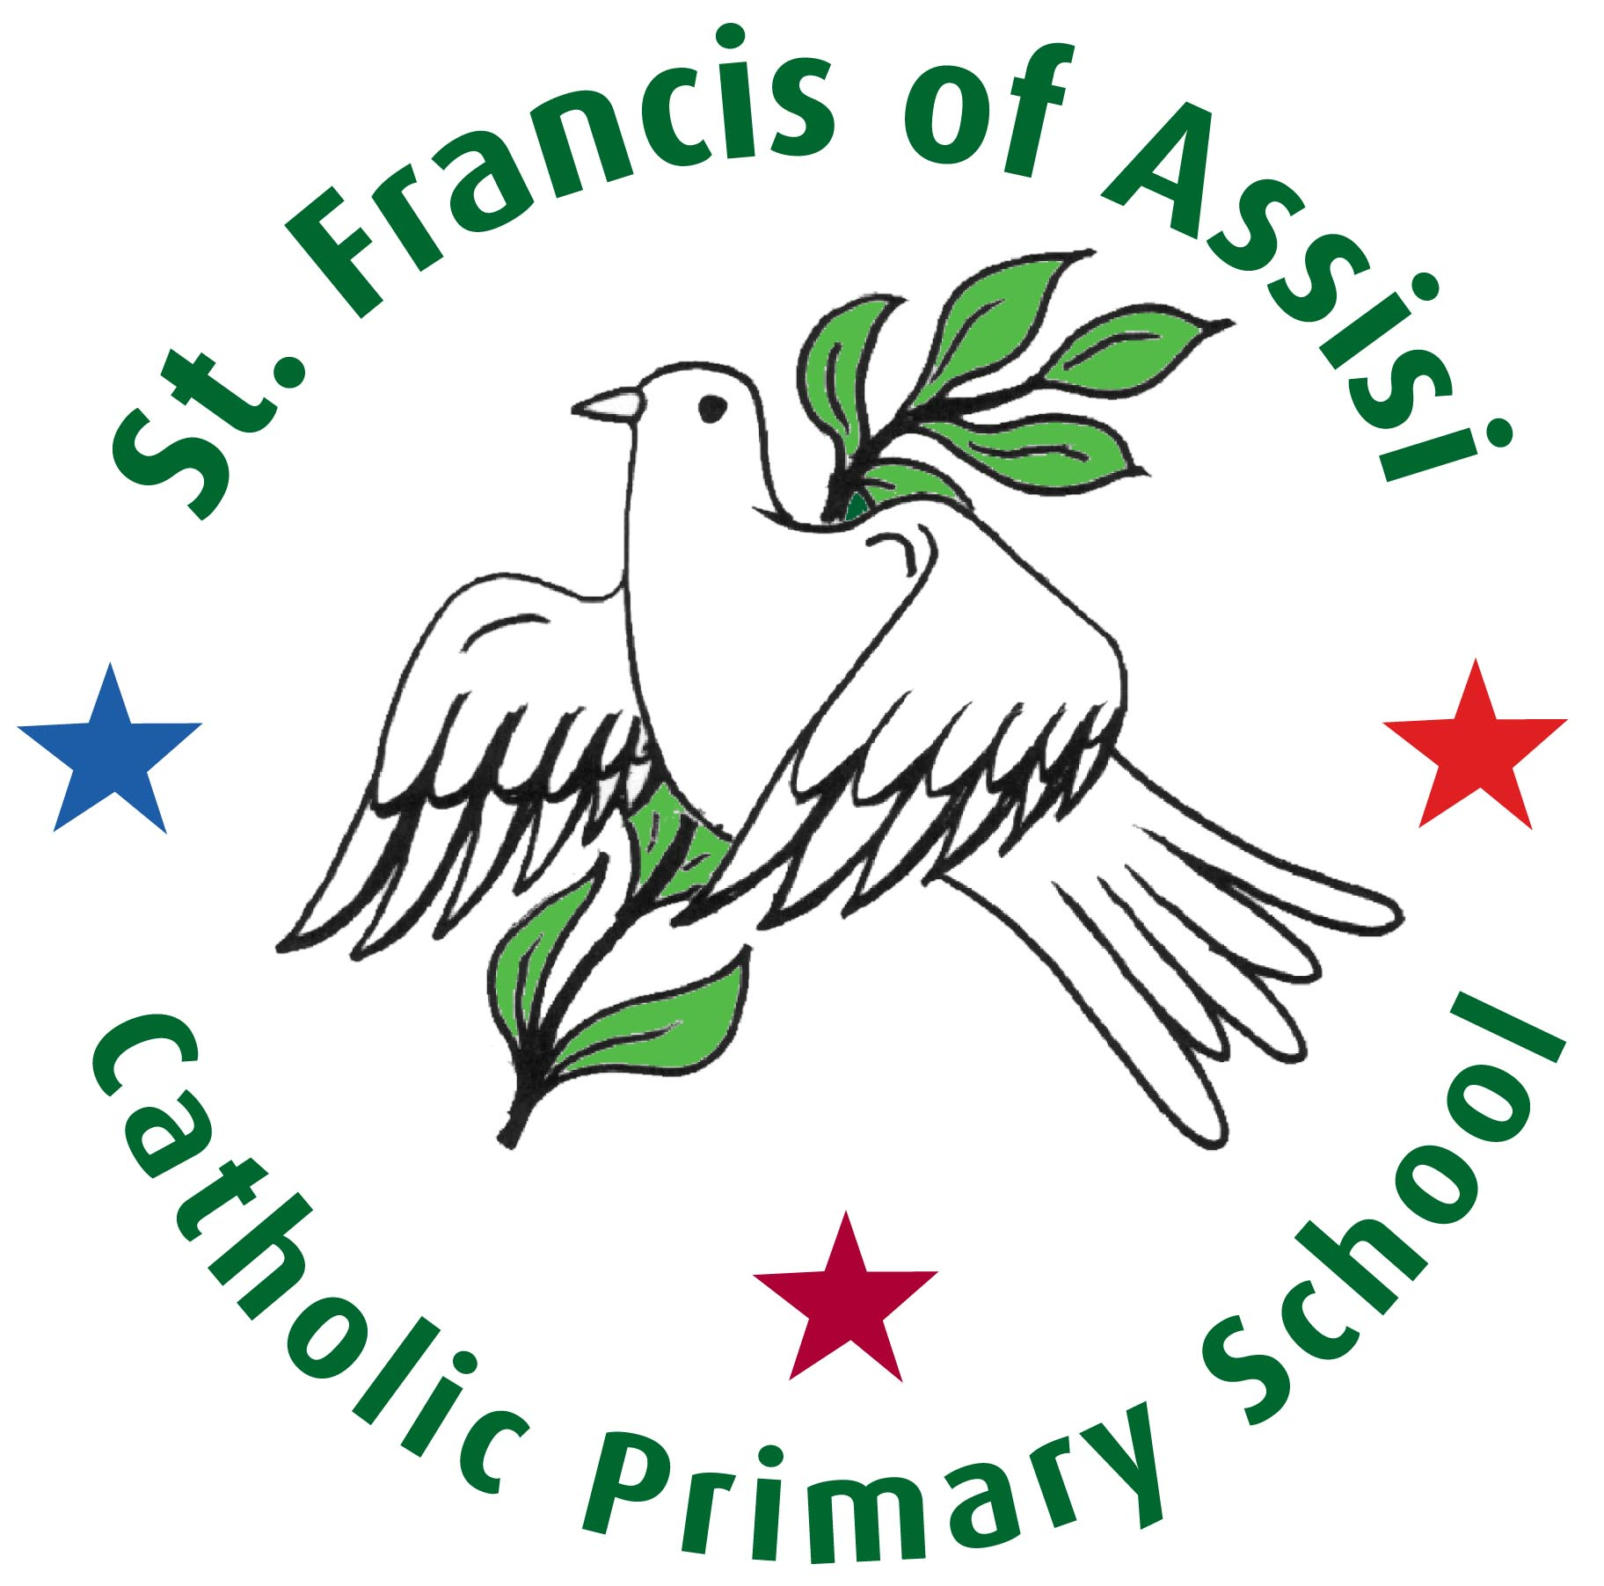

Spiritual, Moral, Social & Cultural Development Policy

At St. Francis of Assisi school

We love and grow in Christ

We live and learn in partnership

We build and share together

RE Coordinator | S. Currie
Chair of Governors | C. Eglin

September 2024

Our Mission Statement

At St. Francis of Assisi school

We love and grow in Christ

We live and learn in partnership

We build and share together

At St Francis of Assisi Catholic Primary School, we recognise that spiritual, moral, social and cultural development is an intrinsic part of a child’s education and fundamental to the development of the individual. We acknowledge that our approach to spiritual, moral, social and cultural development, for all members of our community, must be a sensitive one which allows for enquiry and reflection, without which there would be no motivation to learn.
It will be a process which allows each to acquire insights into personal experience; into the awe and wonder of the world in which we live; into the search for meaning and purpose in life.

We acknowledge the innate dignity and worth of each individual as children of God and the development of the members of St Francis of Assisi school community is concerned with:

‘… the ongoing development of the entire potential of each individual made
in the image and likeness of God and involves finding fulfilment in God
alone.’
(Religious Education in Catholic Schools, Bishops of England and Wales,
2000)

Intent
To ensure that pupils’ experiences, at least in school, are conducive to spiritual, moral, social and cultural growth so that:
- Pupils are open and responsive, aware of themselves and of life’s challenges.
- Pupils are trusting, in themselves, in others and in God.
- Pupils are willing to engage, to take responsibility and to do what is right with courage and hope.
- Pupils will be able to love others, be generous in spirit and respond well to hardship.
- Pupils are encouraged in their spiritual and moral growth by following the example of adult members of the school community, living these values too.

It allies with a holistic view of child education and its promotion provides a framework for children to build their own understanding of the world and to make suitable decisions. In our school we view spiritual and moral education as a process of decision-making based on conscience, self-awareness, knowledge and freedom of responsibility. Our understanding is rooted in the willingness of an individual to see his or her own good in relation to that of the common good:

“The Lord Jesus came to live among us in order to show us the Father’s
love for his friends. And the Lord’s new commandment is at the centre
of our faith: ‘This is my commandment: that you love one another as I
have loved you’. The ‘as’ is a model and a measure of Christian love.”
(The Religious Dimension of Education in the Catholic School, para 85)

We therefore acknowledge that our approach to moral development will be a process that allows each person to gain a sense of the greater good and of what is right and wrong. We endeavour to promote an awareness of conscience, informed by discussion and reflection. It is thus, important to make our children aware of the scope and complexity of morality and its consequent decision-making challenges.

The need to be well informed, to think rationally and impartially across the curriculum about spiritual and moral issues and experience the use of values in decision-making processes are paramount. Through our life in school and our curriculum, we offer: interaction with positive role models; opportunities for discussion; support and advice and personal target setting.

Implementation
Developing each person’s spirituality and morality is the responsibility of the whole school community. Both aspects are made through our discrete curriculum as well as embedded further through additional curricular links and opportunities.
We address spirituality and morality through:
- The teaching of ‘Come and See’.
- ‘A Journey in Love’
- ‘All Are Welcome’
- PSHE
- Collective Worship and assemblies
- Liturgical celebrations
- Citizenship and British values
- Circle time
- Questioning and exploring the meaning of experience
- Cross-curricular approaches where appropriate including art, music and drama
- Reflections
- Sacramental preparations
- Retreat Days during sacramental preparations
- Planned visits to church
- Within the teaching of other faiths

Spiritual and moral development also takes place through:
- Actions
- Relationships and personal interactions, both individually and together
- Unspoken expectations expressed in tone of voice, posture, facial expressions etc.
- How we live-out of our school ethos led by our mission statement
- The degree of welcome we afford visitors
- The planned and maintained environment throughout the school

Our understanding of social and cultural education is based on the Gospel teaching of justice, freedom and peace.
To promote social and cultural development, we provide opportunities for pupils to:
- develop an understanding of their individual and group identity
- learn about service in the school and wider community
- develop their roles as citizens, including play buddies
- begin to understand the Christian responsibility for social justice and concern for the less fortunate
- be taught to appreciate their local environment and to develop a sense of responsibility
- recognise the value and richness of cultural diversity in Skelmersdale, Britain and the world and how these influence individuals and society

Impact
The impact of spiritual, moral, social and cultural development within St Francis of Assisi is of a qualitative nature which impacts upon the whole school ethos and the growth of the individual. It is measured by the extent to which our school provides opportunities for all to develop:
1. An attitude to life based on:
- A development of personal beliefs including religious beliefs;
- An appreciation that people have both individual and shared beliefs on which they base their lives;
- A growing awareness of the way in which personal understanding contributes to personal identity;
- An understanding that one’s inner resources provide the ability to rise above everyday experiences.

2. A sense of awe, wonder and creativity inspired by:
  - The natural world;
  - Mystery;
  - Human achievement with the arts and science.

3. A search for meaning and purpose in life by;
  - Developing appropriate responses to the challenging experiences of life such as beauty, suffering and death;
  - Being concerned by injustice and aggression and their effect on others;
  - A growing awareness of when it is important to control emotions and feelings and how to use such feelings as a source of growth and human experience.

4. Self-awareness and relationships by:
  - Developing self- respect;
  - Fostering an appreciation of the individuality of others;
  - Recognizing that every individual has worth;
  - Building up relationships with others;
  - Fostering a sense of community.

The Spiritual, Moral, Social & Cultural Policy will be reviewed and updated in September 2025.

